PUERTAS LÓGICAS

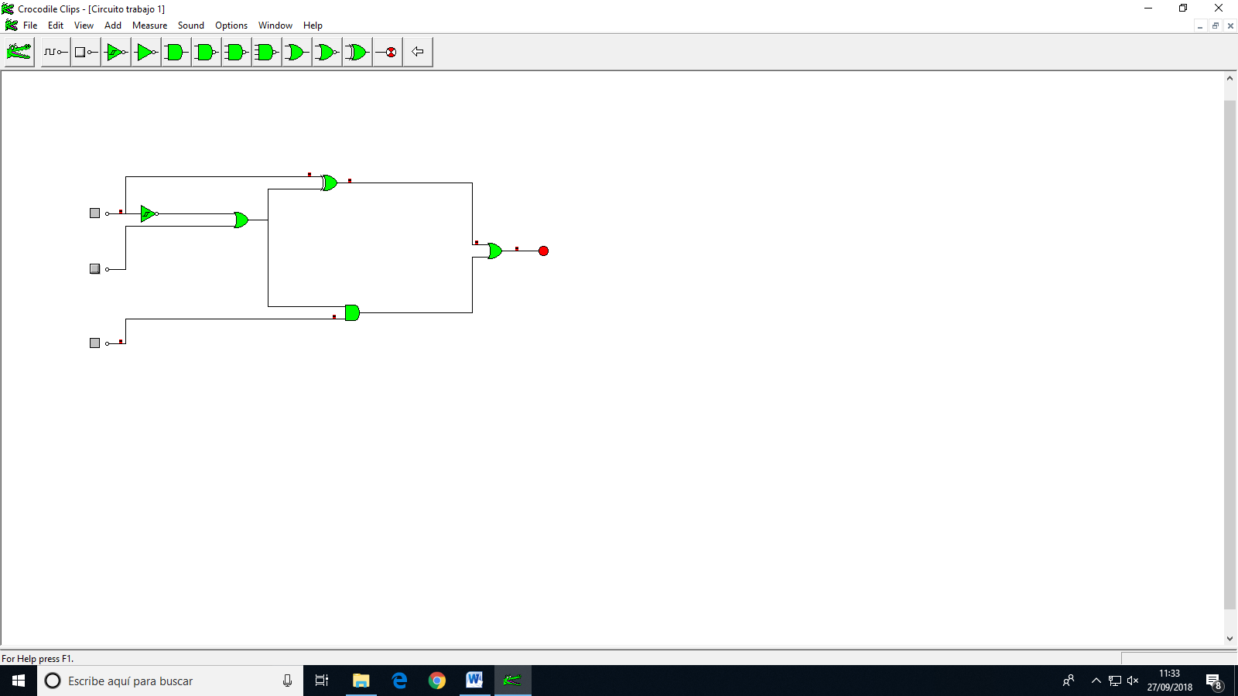

Ecuación del circuito:

a(a+b)+ a(a+b)+(a+b)c

Tabla de verdad

|  |  |  |  |
| --- | --- | --- | --- |
| A | B | C | Total |
| 0 | 0 | 0 | 1 |
| 0 | 0 | 1 | 1 |
| 0 | 1 | 0 | 1 |
| 0 | 1 | 1 | 1 |
| 1 | 0 | 0 | 1 |
| 1 | 0 | 1 | 1 |
| 1 | 1 | 0 | 0 |
| 1 | 1 | 1 | 1 |

Javier Salazar Toledo e Inés Fernández Fernández 2º C Bach